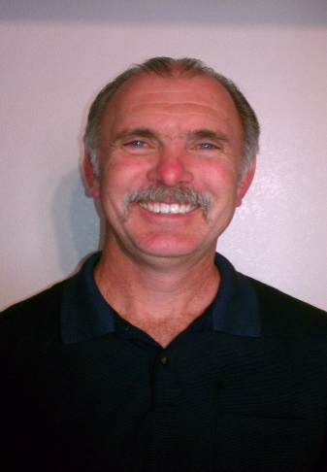
My name is Gary Warskow, and I am a volunteer who is running for the office of band booster president. I am a second generation Arizona native. I have a Bachelor of Science degree in Business Administration and Management with an emphasis in production and materials management. I have worked at Motorola/General Dynamics for the past 33 years, in various capacities. Those include wafer fabrication, electrical/mechanical design of military communications and sensor systems and as a business analyst in IT.

For the past 38 years I have served in leadership roles in high school, various not for profit and charity organizations committees, executive committees, executive boards as either a committee person or a committee chair. I served as the treasurer of my church for nine years, and I served as the DVHS band booster treasurer for three and a half years starting in the 2007-2008 school year. I was elected as Desert Vista Thunder Board Vice President in 2011. I have served in that capacity for 4 years. I served on the band booster’s ad hoc policy and procedures committee. I have served on several bylaw committees, either as a committee person or the committee chair person where new bylaws were written or bylaws were modified. Over the years I have served on several budget committees and nominating committees either as a committee person or as the committee chair. Based on my 38 years of experience, I am very familiar with how various not for profit and charity organizations are run

My goal(s) for the band boosters if elected would be to serve you as booster parents, support and foster an environment where volunteers are encouraged to serve in roles that improve the DV band program as a whole, creating and supporting an exciting first class environment for the students in the DV band program. I will continue to build on the excellent band program already put in place. I firmly believe in an organization of volunteers who selflessly give of their time and skills to better the band program as a whole. I intend to listen to my peers and value the input that is offered by them. I respect all of my peers. I have earned the respect of my peers and many other boosters, and I will do what it takes to earn the respect of those who I do not know.

I accepted the nomination for President, because several of my respected peers within the various organizations of DVHS and outside of DV, many of whom I have already had wonderful working relationships with in years past and those I currently work with, all who strongly believe in my leadership skills. They believe and trust that I have what is necessary to lead a successful organization such as DV’s band boosters, and have nominated me for the office of President. I had a wonderful working relationship with Mr. Thye when I served on the executive board in years past, and I look forward to working with him again. I am familiar with DVHS administration as I interface with them on a regular basis for Thunder Board.

I am running for the office of Band Booster President, because I bring strong, well rounded leadership skills, abilities and qualities to an already successful booster and band program at Desert Vista High School. I want to continue that excellence that is already in place. I want to serve one of the best volunteer organizations in the state. Please vote for me as your next booster president!

