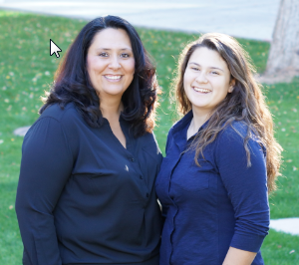
Carrie Schlax – Secretary

Hi! My name is Carrie and I am a sophmore parent this year to Greysen (pictured above with me). Greysen is in the baritone section of the Marching Band and LOVES it! She’s also in the Jazz Band- trombone, Concert Band – bassoon and plays the bass drums in the Steel Band. I have been part of Team Pit for the past couple of years. It is a lot of hard work, but a lot of fun and laughs! It’s a great group of people and I am looking forward to another fun season!
I have accepted the nomination of Secretary to be more involved with the band program. My daughter has a deep love of band – music in general, so I intend on participating to support her. I would like to be part of the team that helps make decisions that allow our kids be part of this wonderful program. My experience in various organizations may help continue this program for many years to come.
My experiences include the following: Chairperson for the Innisbrook Gift Wrap fundraiser for 4 years. I was the Co-Leader, Cookie Mom and bookkeeper for my daughters Girl Scout troop for 7 years. I was the Ahwatukee Neighborhood Cookie Coordinator for 2 years. This position included training, cookie delivery coordination, and communications to 100 troop leaders.
Thank you for your time and consideration.
Sincerely,
Carrie Schlax

